 Robotics Final Proposal

Neil Nie

Mar, 2017

**Introduction:**

Quadcopters are multirotor helicopters that are lifted and propelled by four rotors. They are also known as drones, which are generally quadcopter with filming equipment. Quadcopters are different from traditional fixed wings aircrafts and also helicopters. I believe that quadcopters are better for unman industrial uses. They are generally easier to balance in a fix position in air. They can also carry sensors and cargo. Quadcopters can even fly properly with only two functioning propellers. They are used in many industries, from general aerial research to search and rescue. Building a good, durable quadcopter can have any purposes.

**Problem Statement:**

One of the biggest challenges of creating quadcopters is keeping balance in air. I will design and create a quadcopter that can balance in air and not be disturbed by small winds and turbulences. The second challenge for quadcopters is navigation. Many times, quadcopter will run into powerline or trees. I will try to design a sensor system that will prevent the aircraft from colliding with large obstacles.

**Objectives:**

The goal of the project is to create a quadcopter that can balance in air. Minor wind and turbulence shouldn’t damage or impact the movement of the quadcopter. The quadcopter will also be remote controlled by an iPhone. Ideally, it will be able to avoid large obstacles. If time allows, I will create a program that allows the quadcopter to follow a given path and deliver some goods.

**Proposed Approach**

The frame of the quadcopter will be custom designed and 3d printed. The parts will also be printed with durable, biodegradable material. One extension of the project is to create a frame that can fold in, just like the DJI drone, Mavic Pro.

The quadcopter will be propelled by four 1000kv brushless motors. These motors should provide enough thrust and are generally used in small quadcopter projects like this. To control the speed of these motors, I will use four electronic speed controller (ESC). The combination of those parts will make sure that the quadcopter can lift up, change speed, and also maneuver.

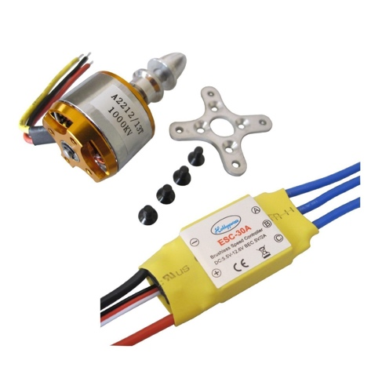

Arduino will function as the main processor of the plane. It will control all the motors and sensors. There are many types of Arduinos, my options are Arduino Uno, or Arduino Mega. Both platforms could support this project.

The quadcopter will be controlled by an iPhone, ideally via Bluetooth. I will write an iOS application for the project. The extension of the project is to create a program so the quadcopter can fly autonomously by follow a preset path.

One of the most important component of the project is the software. I will design and write a PID program for the Arduino for self-balancing purposes. A wireless communication program is also required for the Arduino.

**Project Management**

The project will span from Mid-March to the end of May. During this one and half month period, I have to complete numerous task. Following a schedule is critical, otherwise, there is the high risk of not completing this project on time.

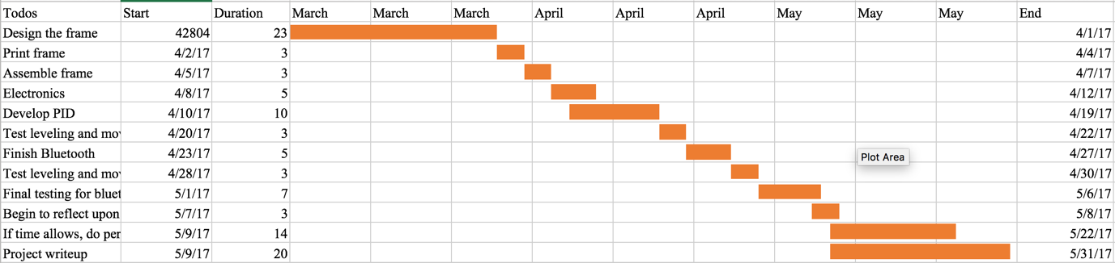

**Deliverables**

The final project will be a finished quadcopter that can balance in air. The quadcopter should be able to lift up, move in all direction and safely land. It should be remote controlled by an iPhone. Ideally, the quadcopter should also be able to detect and avoid surrounding obstacles. The final presentation may have to be done outdoors.

**Learning Goals**

Budget - How much will it cost? This should include required materials and will be used to order materials over spring break.

**Special Topics**